NetSuite Weekly Learning

NetSuite Master Data Architecture
Weekly Learning Series – Week 2

NetSuite Master Data Architecture
A Layered Governance and Financial Control Architecture Framework

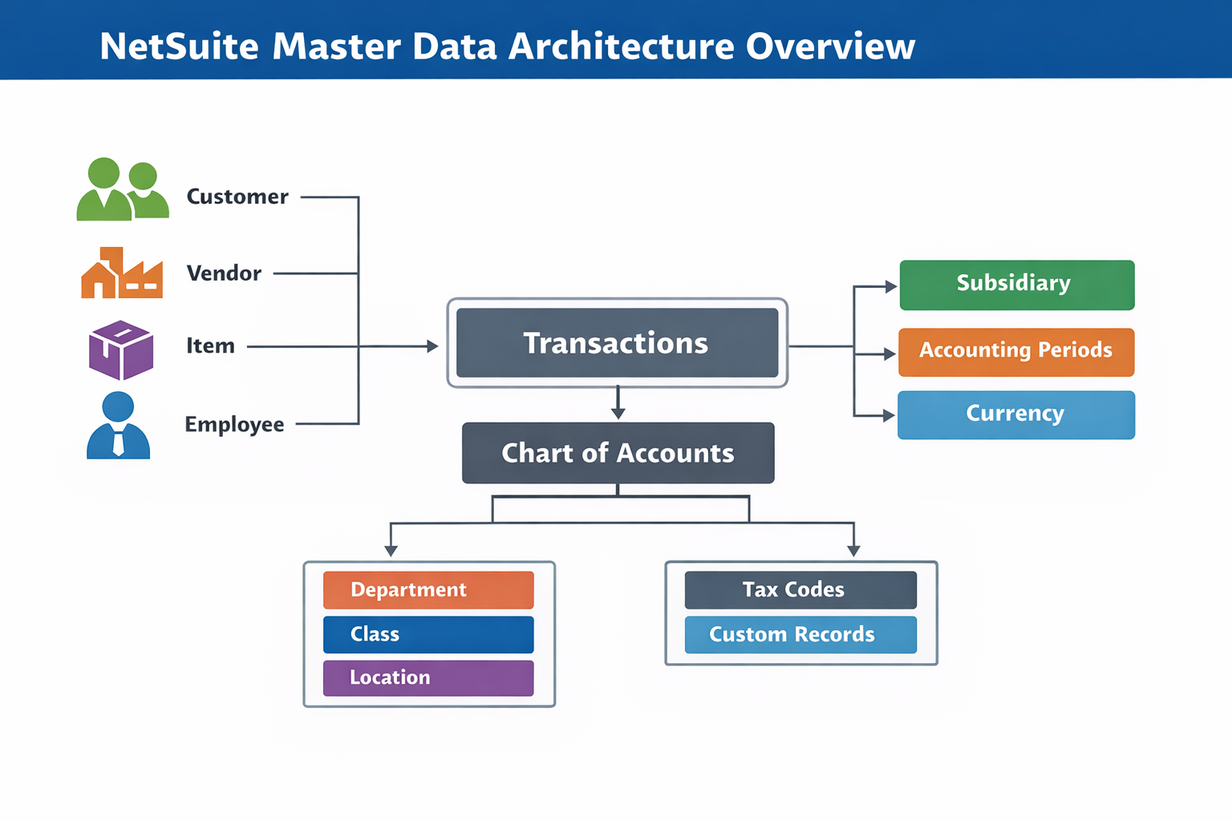

Executive Summary
NetSuite is not driven by transactions alone. It is driven by structured master data. Every transaction, report, workflow, and financial statement depends on the accuracy and governance of underlying master records.
Poorly configured master data leads to reporting inconsistencies, audit risks, performance issues, and operational inefficiencies. Strong master data architecture, on the other hand, ensures financial integrity, system scalability, and long-term maintainability.
This document structures NetSuite Master Data into four architectural layers:
- Core Transactional Masters – Entities directly referenced in daily operations (Customer, Vendor, Item, Employee).
- Financial Architecture Masters – Records that control accounting backbone and reporting integrity (Chart of Accounts, Subsidiary, Accounting Period, Currency).
- Control & Classification Masters – Segmentation and policy drivers (Department, Class, Location, Payment Terms, Price Levels, Tax Codes).
- Advanced & Custom Master Strategy – Custom record design and governance for scalable business-specific solutions.
Together, these layers form a structured master data architecture model designed to support operational efficiency, financial accuracy, technical scalability, and governance control.

Part 1 – Core Transactional Masters

1. Customer
1. Definition
- Represents entities that purchase goods or services from the organization.
2. Key Fields
- Subsidiary
- Currency
- Terms
- Credit Limit
- AR Account
- Price Level
- Entity Status
- Default Billing Address
- Default Shipping Address
- Contact Records
- Credit Hold
- Multi-Subsidiary Customer (If enabled)
3. Used In
- Sales Order
- Invoice
- Cash Sale
- Customer Payment
- Credit Memo
4. GL Impact
- Drives Accounts Receivable (AR) posting
- Directly impacts revenue reporting accuracy
- Controls aging reports
5. Dependencies
- Subsidiary
- Currency
- Terms
- Price Level
- Tax Code
- Accounting Period (Indirectly via transactions)
6. Common Configuration Errors
- Incorrect AR account
- Wrong subsidiary assignment
- Duplicate records
- Inconsistent naming
- Incorrect credit hold configuration
- Missing default address setup
- Improper multi-subsidiary assignment
7. Developer Considerations
- Understand entity joins in Saved Searches
- Use internal ID carefully in scripts
- Avoid unnecessary lookups
- Validate subsidiary and currency mapping

8. Governance Controls
- Restricted creation access
- Duplicate check process
- Periodic master cleanup

2. Vendor
1. Definition
- Represents suppliers providing goods or services.
2. Key Fields
- Subsidiary
- Currency
- Terms
- Payables Account
- Tax Registration
- Vendor Category
- Default Expense Account
- Default Address
- Payment Hold
- Multi-Subsidiary Vendor (If enabled)
3. Used In
- Purchase Order
- Vendor Bill
- Vendor Payment
- Expense Reports

4. GL Impact
- Drives Accounts Payable
- Controls expense recognition
5. Dependencies
- Subsidiary
- Currency
- Terms
- Tax Codes
6. Common Errors
- Incorrect AP account
- Wrong tax configuration
- Duplicate vendor entries
- Incorrect default expense account
- Missing tax registration for statutory reporting
- Payment hold misconfiguration
7. Developer Considerations
- Join optimization in bill searches
- Handle subsidiary restrictions
- Validate tax mapping
8. Governance Controls
- Approval workflow for creation
- Vendor classification standards

3. Item
1. Definition
- Represents products or services sold or purchased.
2. Types
- Inventory Item
- Non-Inventory Item
- Service Item
- Assembly Item
- Kit/Package
3. Key Fields
- Income Account
- Expense Account
- Asset Account
- Costing Method
- Tax Schedule
- Price
- Unit of Measure
- Preferred Vendor
- Inventory Location (for Inventory items)
- Reorder Point
- Cost Estimate Type
4. Used In
- Sales Orders
- Purchase Orders
- Invoices
- Vendor Bills
5. GL Impact
- Revenue posting
- COGS calculation
- Inventory valuation
6. Dependencies
- Chart of Accounts
- Tax Codes
- Price Levels
- Subsidiary
- Units of Measure
- Inventory Locations
- Preferred Vendor
7. Common Errors
- Incorrect GL mapping
- Missing COGS account
- Wrong costing method
- Incorrect unit of measure mapping
- Missing preferred vendor
- Incorrect inventory location setup
8. Developer Considerations
- Avoid heavy joins on item records
- Use search columns efficiently
- Understand costing implications

9. Governance Controls
- GL review before activation
- Item approval workflow
- Naming conventions

4. Employee
1. Definition
- Represents internal users and approval authorities.
2. Key Fields
- Role
- Subsidiary
- Supervisor
- Department
- Access Permissions
3. Used In
- Approval workflows
- Expense reports
- Time tracking
4. System Impact
- Security control
- Workflow routing
- Audit traceability

5. Dependencies
- Role
- Subsidiary
- Department
- Approval Workflows

6. Common Configuration Risks
- Incorrect role assignment
- Improper approval hierarchy
- Excessive permission grants

7. Governance Controls
- Periodic Role audit
- Access review process
- Segregation of duties enforcement

8. Developer Considerations
- Role-based permission validation
- Approval hierarchy logic

Part 2 – Financial Architecture Masters

5. Chart of Accounts
1. Definition
- The structured list of financial accounts used for General Ledger postings.
2. Business Role
- Defines how financial data is categorized and presented in financial statements. It forms the foundation of reporting, compliance, and audit readiness.
3. Key Fields
- Account Number
- Account Type (Asset, Liability, Equity, Income, Expense)
- Parent Account
- Subsidiary (OneWorld)
- Currency (if applicable)
- Eliminate Intercompany (flag)
- Cash flow classification
- System-Controlled Account flag
4. Used In
- All transaction records
- Journal Entries
- Financial Reports
- Budgeting
5. Financial / System Impact
- Determines Balance Sheet and P&L structure
- Drives revenue, expense, and asset classification
- Impacts consolidated financial reporting
- Affects audit traceability
6. Dependencies
- Items (Income / Expense / Asset accounts)
- Customers (AR account)
- Vendors (AP account)
- Tax Codes
- Transactions
7. Common Configuration Risks
- Incorrect account type selection
- Poor numbering structure
- Excessive account creation
- Misconfigured intercompany elimination
- Modifying system-generated accounts
- Incorrect cash flow mapping
- Enabling elimination incorrectly
8. Developer Considerations
- Use account internal IDs carefully in scripts
- Optimize joins in saved searches
- Avoid hardcoding account IDs
- Validate account subsidiary restrictions
9. Governance Controls
- Restricted modification rights
- Structured numbering policy
- Account hierarchy standards
- Periodic GL review process

6. Subsidiary (OneWorld)
1. Definition
- Represents a legal entity or business unit within a multi-entity environment.
2. Business Role
- Controls legal reporting, tax jurisdiction, financial segregation, and operational data visibility.
3. Key Fields
- Parent Subsidiary
- Base Currency
- Tax Registration
- Nexus
- Country
- Elimination Settings
4. Used In
- All transactions
- Customer and Vendor records
- Employee records
- Chart of Accounts
- Financial Consolidation
5. Financial / System Impact
- Controls GL segregation
- Determines reporting structure
- Drives intercompany accounting
- Restricts cross-entity data access
6. Dependencies
- Customers
- Vendors
- Employees
- Items
- Chart of Accounts
- Currency
7. Common Configuration Risks
- Incorrect parent-child structure
- Improper base currency selection
- Cross-subsidiary transaction errors
- Incomplete tax configuration
- Base currency cannot be changed after transactions exist
- Parent subsidiary cannot be modified once transactions exist
- Incorrect elimination subsidiary setup
8. Developer Considerations
- Always apply subsidiary filters in searches
- Validate subsidiary before record creation
- Avoid cross-subsidiary joins without intent
- Handle intercompany logic carefully
9. Governance Controls
- Controlled subsidiary creation
- Approval for structural changes
- Periodic intercompany review
- Data visibility policy enforcement

7. Accounting Period
1. Definition
- Defines the fiscal calendar structure used for transaction posting and reporting.
2. Business Role
- Controls financial cut-off, compliance, and reporting accuracy.
3. Key Fields
- Period Name
- Start Date
- End Date
- Is Posting Period
- A/R Locked
- A/P Locked
- Payroll Locked
- All GL Locked
4. Used In
- All financial transactions
- Journal Entries
- Financial Reports
- Budgeting
5. Financial / System Impact
- Controls posting eligibility
- Enables period locking
- Protects historical financial data
- Drives monthly and yearly reporting
6. Dependencies
- Subsidiary
- Transactions
- GL Accounts
- Financial Reports
7. Common Configuration Risks
- Posting to closed periods
- Improper locking sequence
- Overlapping fiscal calendars
- Delayed period close process
- Closing period without subledger reconciliation
- Partial locking misconfiguration
8. Developer Considerations
- Validate open period before posting via script
- Handle locked period errors gracefully
- Avoid hardcoded period references
- Consider governance impact during bulk processing
9. Governance Controls
- Period close checklist
- Segregation of duties for closing
- Locking policy enforcement
- Audit trail review

8. Currency
1. Definition
- Defines the monetary units used in transactions and financial reporting.
2. Business Role
- Enables multi-currency operations, exchange rate handling, and consolidated reporting.
3. Key Fields
- Currency Code
- Symbol
- Base Currency Indicator
- Precision
4. Used In
- Customer and Vendor records
- Transactions
- Subsidiaries
- Consolidation
5. Financial / System Impact
- Drives exchange rate calculations
- Impacts realized and unrealized gains/losses
- Enables revaluation entries
- Affects consolidated financial statements
- Uses exchange rate types such as Current, Historical, and Average for financial reporting and consolidation.
6. Dependencies
- Customer
- Vendor
- Subsidiary
- Chart of Accounts
- Transactions
7. Common Configuration Risks
- Manual rate overrides
- Incorrect base currency mapping
- Inconsistent exchange rate updates
- Ignoring revaluation process
8. Developer Considerations
- Handle multi-currency joins carefully
- Use exchange rate APIs appropriately
- Avoid assuming base currency
- Validate currency before transaction creation
9. Governance Controls
- Controlled exchange rate updates
- Revaluation approval process
- Currency enablement policy
- Periodic rate audit review

Part 3 – Control & Classification Masters

9. Department / Class / Location
1. Definition
- Classification masters used to segment transactions for reporting and profitability analysis.
2. Business Role
- Enable multidimensional financial reporting across divisions, cost centers, product lines, and physical locations.
3. Key Fields
- Name
- Parent (Hierarchy)
- Subsidiary (if OneWorld)
- Inactive Status
4. Used In
- Sales Orders
- Purchase Orders
- Invoices
- Vendor Bills
- Journal Entries
- Payroll
- Financial Reports
5. Financial / System Impact
- Enables segment-based P&L reporting
- Drives profitability analysis by division or branch
- Impacts budgeting and forecasting
- Enhances management reporting clarity
6. Dependencies
- Subsidiary
- Employees
- Customers
- Vendors
- Transactions
- Chart of Accounts (for reporting segmentation)
7. Common Configuration Risks
- Over-segmentation creating reporting complexity
- Inconsistent usage across transactions
- Poor hierarchy design
- Inconsistent mandatory classification enforcement across forms
8. Developer Considerations
- Use proper joins when retrieving classification data
- Validate mandatory classification fields in scripts
- Avoid hardcoding classification IDs
- Optimize searches when filtering by segment
9. Governance Controls
- Standardized naming conventions
- Defined hierarchy approval
- Mandatory classification policy
- Periodic cleanup of unused segments

10. Payment Terms
1. Definition
- Defines payment schedules and due date calculation rules for receivables and payables.
2. Business Role
- Controls credit policies, vendor obligations, and cash flow timing.
3. Key Fields
- Term Name
- Due Days
- Discount Percentage
- Discount Days
- Installment Structure (if applicable)
- Date Driven Terms
- Installment Terms Flag
4. Used In
- Customer records
- Vendor records
- Invoices
- Vendor Bills
- Sales Orders
5. Financial / System Impact
- Drives AR aging reports
- Drives AP aging reports
- Impacts cash flow forecasting
- Affects discount recognition
- Influences early payment discount postings
6. Dependencies
- Customer
- Vendor
- Currency
- Transactions
- Accounting Period
7. Common Configuration Risks
- Incorrect due date logic
- Misaligned discount configuration
- Overlapping or redundant terms
- Improper default term assignment
8. Developer Considerations
- Validate due date calculation logic in scripts
- Avoid hardcoding term IDs
- Handle installment terms carefully in automation
- Consider term impact during bulk transaction creation
9. Governance Controls
- Credit policy alignment
- Approval for new term creation
- Periodic review of active terms
- Standardized naming structure

11. Price Levels
1. Definition
- Defines standardized pricing strategies applied across customers and items.
2. Business Role
- Ensures pricing consistency, supports tiered pricing models, and controls margin strategy.
3. Key Fields
- Price Level Name
- Base Price Reference
- Currency
- Applicable Customer Group
- Base Price
4. Used In
- Customer records
- Item records
- Sales Orders
- Invoices
- Estimates
5. Financial / System Impact
- Drives revenue consistency
- Influences gross margin
- Supports volume-based pricing
- Impacts profitability reporting
6. Dependencies
- Customer
- Item
- Currency
- Subsidiary
7. Common Configuration Risks
- Incorrect price mapping
- Uncontrolled custom price overrides
- Duplicate price levels
- Currency mismatch
- Price level not aligned with currency configuration
8. Developer Considerations
- Handle price retrieval logic carefully in scripts
- Optimize pricing joins in saved searches
- Avoid overriding pricing without validation
- Validate currency compatibility
9. Governance Controls
- Approval for new pricing structures
- Margin review policy
- Periodic price audit
- Restriction on manual overrides

12. Tax Codes / Tax Items
1. Definition
- Defines indirect tax calculation rules applied to transactions.
- Behavior differs under Legacy Tax and SuiteTax engines
2. Business Role
- Ensures statutory compliance and accurate indirect tax calculation.
3. Key Fields
- Tax Code Name
- Tax Rate
- Tax Type
- Agency
- Subsidiary (if applicable)
4. Used In
- Sales Orders
- Invoices
- Purchase Orders
- Vendor Bills
- Journal Entries (tax adjustments)
5. Financial / System Impact
- Drives automatic tax calculation
- Impacts tax liability accounts
- Affects statutory reporting
- Influences compliance audits
6. Dependencies
- Customer
- Vendor
- Item
- Subsidiary
- Chart of Accounts
- Nexus
7. Common Configuration Risks
- Incorrect tax rate setup
- Wrong tax agency mapping
- Manual overrides bypassing compliance
- Inconsistent tax code assignment
8. Developer Considerations
- Validate tax code before transaction save
- Handle multi-subsidiary tax logic carefully
- Avoid bypassing native tax engine
- Optimize tax joins in reporting searches
- SuiteTax vs Legacy Tax API behaviour differences
9. Governance Controls
- Restricted tax configuration access
- Compliance review process
- Periodic tax rate validation
- Audit trail monitoring

Part 4 – Advanced & Custom Master Strategy

13. Custom Records as Master Data
1. Definition
- User-defined master entities created to support business-specific processes not covered by standard NetSuite records.
2. Business Role
- Provide structured control over custom workflows, approval hierarchies, pricing models, project governance, contractual rules, and operational logic.
3. Key Fields
- Record Name
- Parent (for hierarchy, if applicable)
- Linked Standard Record (Customer, Project, Item, etc.)
- Effective Date / Status
- Custom Segmentation Fields
- Internal ID (system controlled)
- Record Type ID
- Access Type
- Allow Attachment Flag
- Use Permission Flag
4. Used In
- Custom Workflows
- SuiteScripts
- Saved Searches
- Suitelets / RESTlets
- Approval Engines
- Reporting & Dashboards
5. Financial / System Impact
- Drives automation logic
- Controls approval routing
- Impacts revenue or cost recognition (if integrated with transactions)
- Influences reporting accuracy
- Can significantly affect system performance
6. Dependencies
- Standard Records (Customer, Vendor, Item, Project, Employee)
- Subsidiary
- Department / Class / Location
- Transactions
- Workflows & Scripts
7. Common Configuration Risks
- Creating unnecessary custom masters
- Lack of parent-child structure
- No indexing on frequently searched fields
- Circular dependencies
- Excessive field-level customization
- Poor naming conventions
8. Developer Considerations
- Avoid governance-heavy loops in scripts
- Use indexed fields for search optimization
- Maintain referential integrity between records
- Avoid hardcoding internal IDs
- Implement defensive validation logic
- Design for scalability, not immediate convenience
9. Governance Controls
- Architecture review before creation
- Documentation of purpose and dependencies
- Approval for structural changes
- Periodic cleanup of unused records
- Performance monitoring
- Script ID naming standards
- Permission matrix documentation
- Change impact assessment before modification

Closing Summary
- Sustainable NetSuite implementations rely on disciplined master data governance built on the following principles:
- Configuration Discipline – Controlled creation and modification of core masters.
- Financial Alignment – Direct mapping between operational records and accounting structure.
- Technical Scalability – Script-safe design, optimized searches, and minimal performance overhead.
- Governance Enforcement – Role-based access control, approval workflows, and periodic reviews.
- Continuous Review – Regular cleanup, structural validation, and impact assessment before changes.

- When master data is structured correctly, reporting becomes reliable, automation becomes predictable, and customization remains scalable.
- Strong systems are not built by adding scripts first. They are built by designing master data correctly from the start.

